CPE301 – SPRING 2020

Design Assignment 3B

Student Name: Jason Villanueva

Student #: 2001255420

Student Email: villaj21@unlv.nevada.edu

Primary Github address: <https://github.com/jasonvillanuevagit/submission_designAssignments->Directory: <https://github.com/jasonvillanuevagit/submission_designAssignments-/tree/master/DesignAssignment3B>

1. **COMPONENTS LIST AND CONNECTION BLOCK DIAGRAM w/ PINS**

Atmel Studio 7.0 Atmega328PB-Xmini PC LM-35

- Assembler

- Simulator

- Debugger

- Terminal

1. **INITIAL/MODIFIED/DEVELOPED CODE OF TASK 1/A**

DA_3B C Code

#define BAUD 9600

#define F_CPU 16000000UL

#include <avr/io.h>

#include <util/delay.h>

#include <util/setbaud.h>

#include <avr/interrupt.h>

#include <stdlib.h>

#include <stdio.h>

//"Global variable"

volatile uint8_t Overflow;

//"Global variable"

volatile float adc_temp_F;

volatile float adc_temp_C;

//FUNCTION TO INITIALIZE USART

void USART_init(void){

UBRR0H = UBRRH_VALUE;

UBRR0L = UBRRL_VALUE;

UCSR0C = _BV(UCSZ01) | _BV(UCSZ00);//8-BIT DATA

UCSR0B = _BV(RXEN0) | _BV(TXEN0);//ENABLE RX AND TX

}

//FUNCTION TO INITIALIZE ADC

void adc_init(void){

ADMUX = (0<<REFS1) | //REFERENCE SELECTION BITS

(1<<REFS0) | //AVcc -External cap at AREF 5V

(0<<ADLAR) | //ADC RIGHT ADJUST RESULT

(1<<MUX2) | //ANALOG CHANNEL SELECTION BITS

(0<<MUX1) | //ADC4 (PC4) CHANNEL 4

(0<<MUX0);

ADCSRA = (1<<ADEN) | //ADC ENABLE

(0<<ADSC) | //ADC START CONVERSION

(0<<ADATE) | //ADC auto trigger enable

(0<<ADIF) | //ADC interrupt flag

(0<<ADIE) | //ADC interrupt enable

(1<<ADPS2) | //ADC PRESCALAR SELECTION BITS

(1<<ADPS1) | //128 AS PRESCALAR SEL. BITS

(1<<ADPS0);

}

//FUNCTION THAT SETS TIMER/INTERRUPT REGISTERS

void set(){

TCCR0A = 0;//NORMAL MODE OPERATION

TCCR0B = 0X05;//THE PRESCALER SET TO 1024

TCNT0 = 0X00;//COUNTER VALUE = 0

TIMSK0 = (1<<TOIE0);//ENABLE INTERRUPT

sei();//ENABLE GLOBAL INTERRUPT

}

//INTERUPT SUBROUTINE FOR TIMER 0

ISR(TIMER0_OVF_vect){

Overflow++;//INCREMENT OVERFLOW

}

//FUNCTION THAT READS IN 1 CHAR AT A TIME

void USART_tx_string(char*data){

//CONTROL ENTERS WHILE DATA REG NOT EMPTY

while((*data!='\0')){

//WAIT FOR BUFFER REGISTER TO CLEAR

while(!(UCSR0A & (1 << UDRE0)));

UDR0 = *data;//REGESTER EQUALS DATA

data++;//DATA MOVES POSITION

}

}

void read_adc_F(void){

unsigned char i = 10;//Variable for sample amounts

adc_temp_F = 0;//Initialize adc_temp_F

while(i--){

ADCSRA |= (1<<ADSC);//Enable Start Conversion

while(ADCSRA & (1<<ADSC));//Wait until enable & start conversion

adc_temp_F += ADC;//LM35 value added & stored into adc_temp_F

}

adc_temp_F = (adc_temp_F/10) + 6;//Average of LM35 values

adc_temp_C = (adc_temp_F - 32) * 5 / 9;

}

int main(void){

USART_init();//Initialize USART

adc_init();//Initialize ADC

set();//Initialize Timers/Interrupts

char char_array_F[20];//Character array of 20 for float F

char char_array_C[20];//Character array of 20 for float C

while (1){

//CONTROL WILL ENTER IF OVERFLOW >= 30 CYCLES ~.5sec

if (Overflow == 30){

read_adc_F();//Call Read Functions

snprintf(char_array_F,sizeof(char_array_F), "%f\r\n", adc_temp_F);

snprintf(char_array_C,sizeof(char_array_C), "%f\r\n", adc_temp_C);

//Prints temperature value

USART_tx_string("\n");

USART_tx_string("Temp in F: ");

USART_tx_string(char_array_F);

USART_tx_string("Temp in C: ");

USART_tx_string(char_array_C);

USART_tx_string("\n");

//Overflow reset to 0

Overflow = 0;

}

}

}

1. **DEVELOPED MODIFIED CODE OF TASK 2/A from TASK 1/A**

N/A

1. **SCHEMATICS**

N/A

1. **SCREENSHOTS OF EACH TASK OUTPUT (ATMEL STUDIO OUTPUT)**

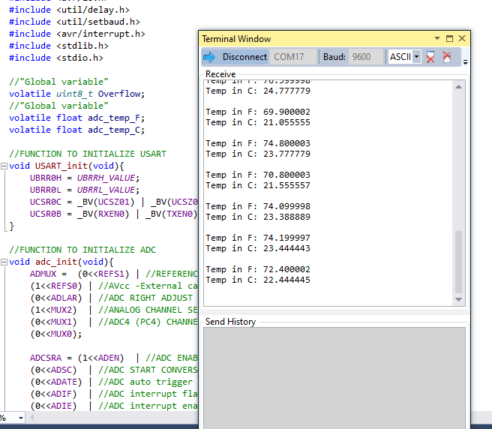

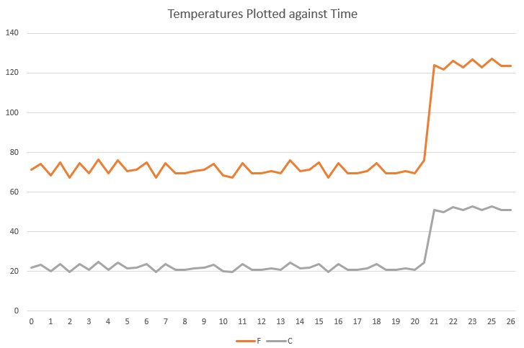

1. **SCREENSHOT OF EACH DEMO (BOARD SETUP)**

1. **VIDEO LINKS OF EACH DEMO**

YouTube Video Demo Link

<https://youtu.be/a4A9_KwFtGc>

1. **GITHUB LINK OF THIS DA**

<https://github.com/jasonvillanuevagit/submission_designAssignments-/tree/master/DesignAssignment3B>

**Student Academic Misconduct Policy**

<http://studentconduct.unlv.edu/misconduct/policy.html>

“This assignment submission is my own, original work”.

Jason Villanueva